1. 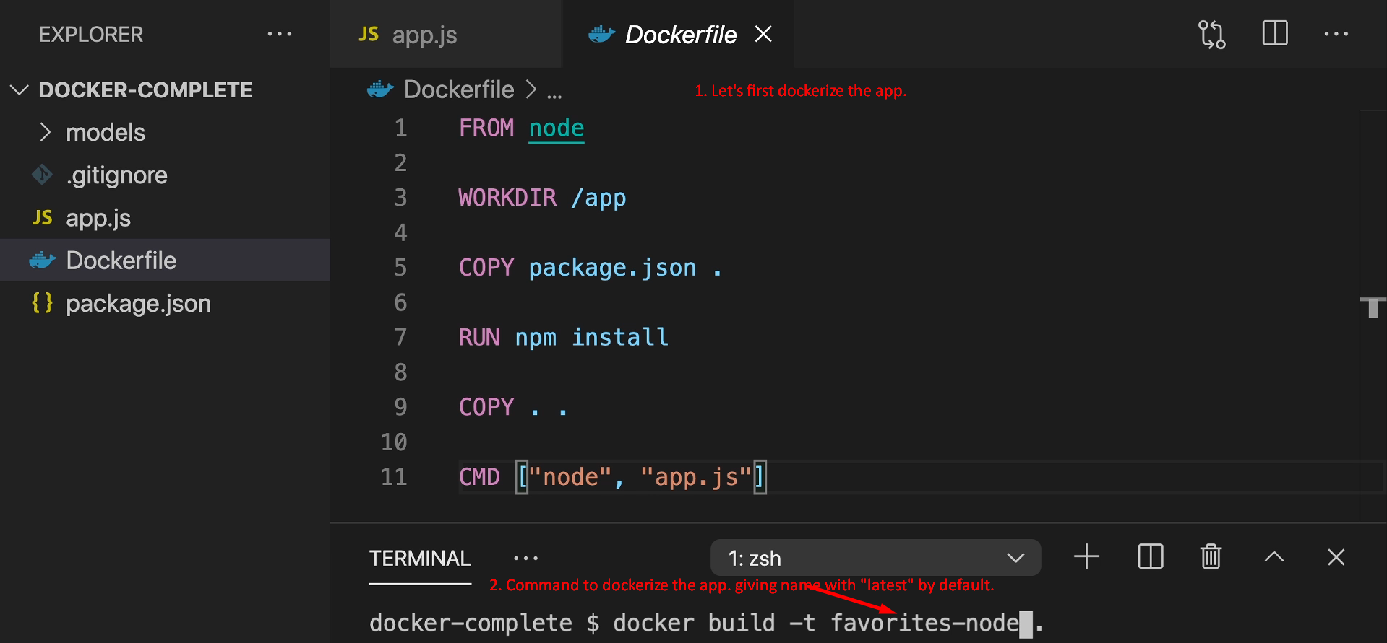
2. 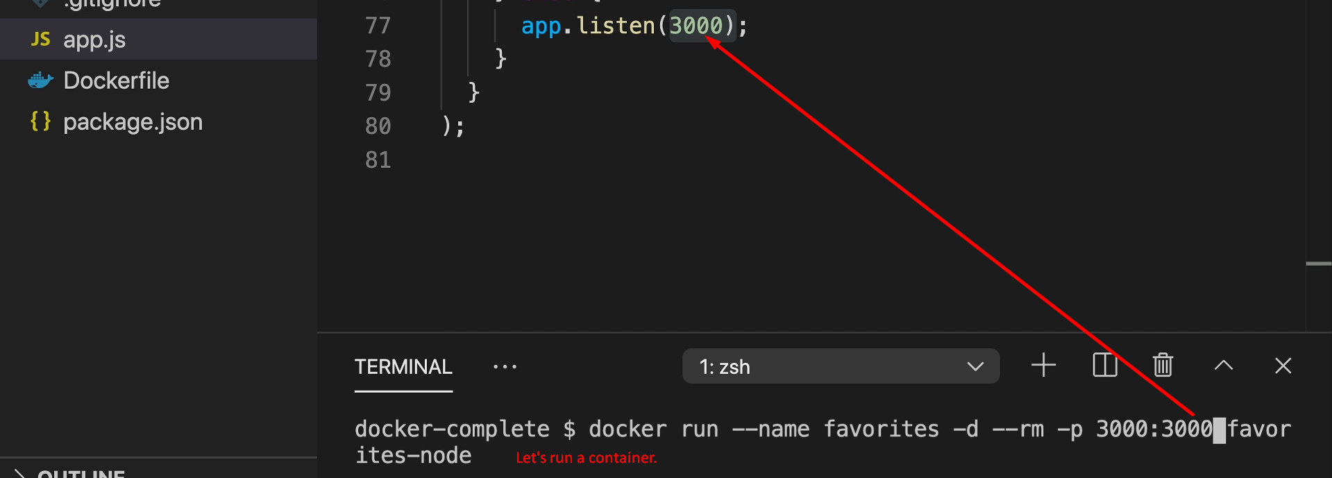
3. As this containerized app is using MongoDB so the above container creation command will not run successfully.  
   So, remove -d and try to run a container again.  
   This time you will see the following error on the console.   
     
   It means while making connection to something running on Host machine (in our case MongoDB) got failed but we know MongoDB is running properly on Host machine.  
   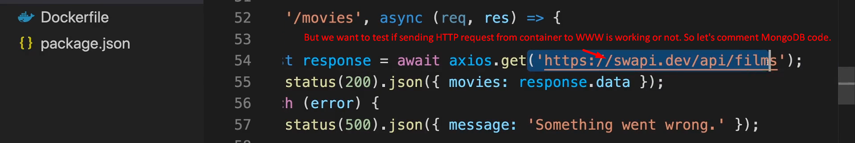  
   Graphical user interface, text

   Description automatically generated
4. 
5. 
6. Graphical user interface, text, application, email

   Description automatically generated
7. 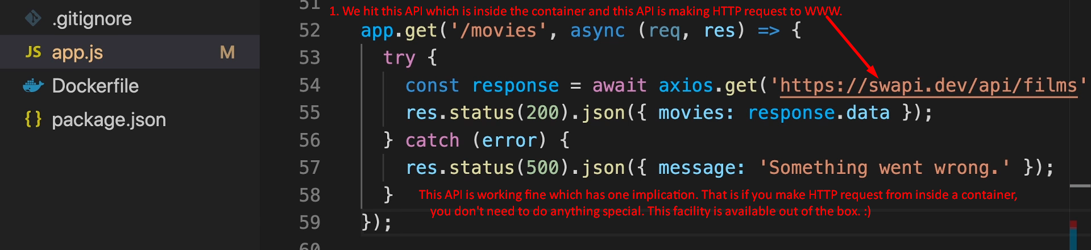
8. Diagram, timeline

   Description automatically generated